Session 2026-2027

Vision:Dream of where you want. | Mission: Means to achieve Vision

Program Educational Objectives of the program (PEO): (broad statements that describe the professional and career accomplishments)
PEO1 | Preparation | P: Preparation | Pep-CL abbreviation  pronounce as Pep-si-lL easy to recall
PEO2 | Core Competence | E: Environment (Learning Environment) | Pep-CL abbreviation  pronounce as Pep-si-lL easy to recall
PEO3 | Breadth | P: Professionalism | Pep-CL abbreviation  pronounce as Pep-si-lL easy to recall
PEO4 | Professionalism | C: Core Competence | Pep-CL abbreviation  pronounce as Pep-si-lL easy to recall
PEO5 | Learning Environment | L: Breadth (Learning in diverse areas) | Pep-CL abbreviation  pronounce as Pep-si-lL easy to recall

Program Outcomes (PO): (statements that describe what a student should be able to do and know by the end of a program)
Keywords of POs:
Engineering knowledge,Problem analysis, Design/development of solutions,Conduct Investigations of Complex Problems, Engineering Tool Usage, The Engineer and The World,Ethics, Individual and Collaborative Team work,Communication, Project Management and Finance, Life-Long Learning

PSO Keywords: Cutting edge technologies, Research

“I am an engineer, and I know how to apply engineering knowledge to investigate, analyse and design solutions to complex problems using tools for entire world following all ethics in a collaborative way with proper management skills throughout my life.” to contribute to the development of cutting-edge technologies and Research.

Integrity: I will adhere to the Laboratory Code of Conduct and ethics in its entirety.

Name and Signature of Student and Date
(Signature and Date in Handwritten)

Session | 2024-25 (ODD) |  | Course Name | Web Technology Lab
Semester | 3 |  | Course Code | 23CT1301
Roll No | 14 |  | Name of Student | MANJIRI BHAISE
Practical Number |  | 7
Course Outcome |  | The aim of this practical is to understand asynchronous programming in JavaScript using Fetch API, Promises, and async/await. Students learn how to fetch real-time weather data from a public API and display it dynamically on a web page. This practical helps students understand how JavaScript communicates with external servers and handles responses without blocking the execution of the program. Students also learn to convert API responses into JSON format, handle errors using try-catch, and update webpage content using DOM manipulation. By completing this practical, students gain basic knowledge of API integration and asynchronous programming for developing interactive web applications.
Aim |  | To develop a Weather App using HTML, CSS, and JavaScript to fetch and display weather data from a public API using Fetch API and async/await.
Problem Definition |  | JavaScript — Asynchronous Programming (Fetch/Promises)  Sample Problem Statement: Build a small Weather App or Movie-Search App that fetches  data from ONE public API using fetch()/async-await and renders it dynamically.
Theory  (100 words) |  | Asynchronous programming allows JavaScript to perform tasks such as fetching data from a server without blocking the execution of other code. The Fetch API is used to send requests to a public API and receive responses. A Promise represents the eventual success or failure of an asynchronous operation. The async and await keywords make asynchronous code easier to read and understand. In a Weather App, the application fetches weather information from a public API and displays details such as temperature, humidity, and wind speed dynamically on the webpage.
Procedure and Execution  (100 Words) |  | Create a folder named WeatherApp.  Create three files: index.html, style.css, and script.js.  Write HTML code to create a search box, button, and result area.  Apply CSS to style the webpage.  Write JavaScript code using fetch(), async/await, and try-catch.  Use a public weather API to fetch weather information for the entered city.  Convert the API response into JSON format.  Display the temperature, humidity, and wind speed dynamically on the webpage.  Open index.html in a web browser and ensure that the internet connection is active.  Enter a city name and click the Search button to view the weather details.
CODE:
HTML
<!DOCTYPE html>
<html>
<head>
<title>Weather App</title>
<link rel="stylesheet" href="style.css">
</head>
<body>

<div class="container">
<h1>Weather App</h1>

<input type="text" id="city"
placeholder="Enter city name">

<button onclick="getWeather()">Search</button>

<div id="result"></div>
</div>

<script src="script.js"></script>
</body>
</html>
Css
body {
font-family: Arial;
background-color: lightblue;
text-align: center;
}

.container {
background-color: white;
width: 300px;
margin: 100px auto;
padding: 25px;
border-radius: 10px;
}

input {
padding: 10px;
width: 85%;
margin-bottom: 10px;
}

button {
padding: 10px 20px;
background-color: blue;
color: white;
border: none;
cursor: pointer;
}

#result {
margin-top: 20px;
}
JAVA SCRIPT
async function getWeather() {
let city = document.getElementById("city").value;
let result = document.getElementById("result");

if (city === "") {
result.innerHTML = "Please enter a city name!";
return;
}

try {
result.innerHTML = "Loading...";

// Get city coordinates
let url1 = "https://geocoding-api.open-meteo.com/v1/search?name="
+ encodeURIComponent(city) + "&count=1";

let response1 = await fetch(url1);
let data1 = await response1.json();

if (!data1.results) {
result.innerHTML = "City not found!";
return;
}

let place = data1.results[0];
let lat = place.latitude;
let lon = place.longitude;

// Get weather data
let url2 = "https://api.open-meteo.com/v1/forecast?latitude="
+ lat + "&longitude=" + lon
+ "&current=temperature_2m,relative_humidity_2m,wind_speed_10m";

let response2 = await fetch(url2);
let data2 = await response2.json();

result.innerHTML =
"<h2>" + place.name + "</h2>" +
"<p>Temperature: " +
data2.current.temperature_2m + " °C</p>" +
"<p>Humidity: " +
data2.current.relative_humidity_2m + "%</p>" +
"<p>Wind Speed: " +
data2.current.wind_speed_10m + " km/h</p>";

} catch (error) {
result.innerHTML = "Error fetching weather data!";
}
}
 |  | Output: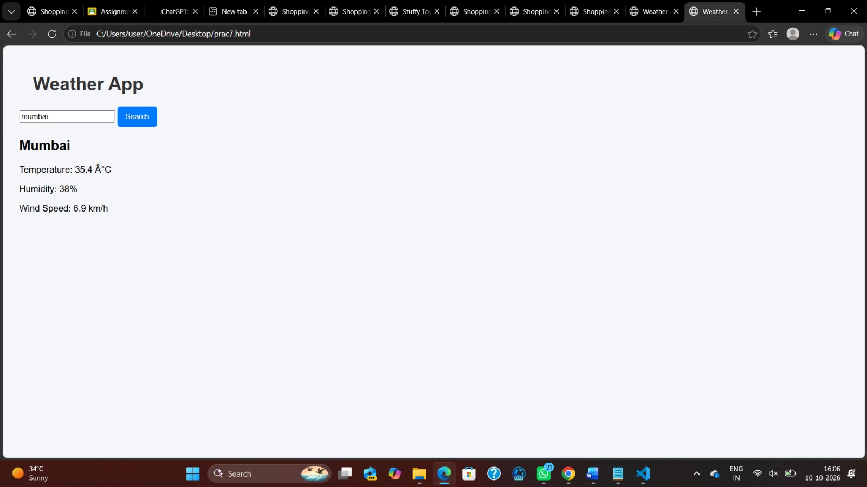
Link of student Github profile where lab assignment has been uploaded |  | https://github.com/manjiribhaise.com
Conclusion |  | Thus, the Weather App was successfully developed using HTML, CSS, and JavaScript. The practical demonstrated the use of Fetch API, Promises, async/await, and error handling to retrieve data from a public API. It also helped in understanding dynamic webpage updates using DOM manipulation. Ni
Plag Report (Similarity index < 12%) |  | - The submitted work was checked for similarity with existing sources. The similarity index is less than 12%, indicating that the content is largely original and independently prepared. Any minor similarities may be due to commonly used technical terms, programming syntax, or standard explanations related to JavaScript and form validation.
Date |  | 05/10/26

